By: Aaron Makin (Master Geek!)

Introduction

There are 5 simple phases to build a machine:
- Concept Phase – Forming the vision for the machine
- Step Building Phase – Designing the main steps of the machine
- Linking Phase – Linking the main steps together
- Test Phase – Testing the entire machine
- Performance Phase – Running the machine for all to see

- Concept Phase

- Gather a Team
  - Look for diverse backgrounds. The best team is a diverse team!
  - It should include, but not limited to…
    - someone that likes to build mechanical objects
    - someone that knows a lot about electrical devices
    - someone that is crafty and creative
    - someone who is brand new to the experience
- Read the Rules
  - Know them and memorize them. Know them inside and out.
  - Ask questions up front for clarification.
  - Don’t stretch the rules.
- Identify and research the theme
  - Decide on your unique theme. Spend lots of time thinking about this.
  - Sometimes the theme won’t come to you until you’re halfway through building your machine
- Brainstorm Steps
  - Seek inspiration from…
    - the other machines in last year’s contest
    - YouTube (search Rube Goldberg, chain reaction, mousetraps)
    - Purdue Contest web.ics.purdue.edu/~pe/)
    - RubeGoldberg.com
    - arthurganson.com
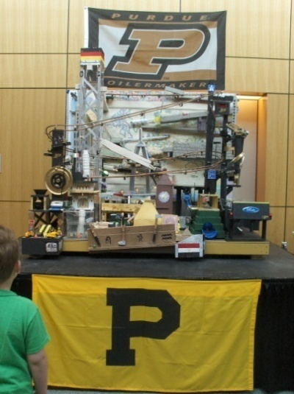

- Step Building Phase

- Collect the materials
  - Garage sales
    - Unique objects
    - Objects with motors
    - Objects that make noise
    - Objects that are complex
  - Hardware stores - Lumber, Hardware, Tools
  - Toy stores, Hobby stores
- Look around for building materials
  - Have them all visible when building
  - You will find solutions just by looking around the room
  - You can either build the step from scratch, using wood or plastic OR you can use something that is already built to make the step
  - For example, if you have a ball falling from one ramp to the other you can either use a piece of bought wood cut to the exact length or you can use a toilet paper core
- Many different options for quick and easy fastening
  - Duct tape is good for light loads
  - Rubber bands are good for medium loads
  - Zip ties are good for heavy loads
  - Screws and bolts are more permanent but provide good support for large loads
- Fail Fast
  - Try to build the initial design fast to see if it’s going to work, if it doesn’t, try another design quickly rather than spending more time getting the original design to work
  - Only 20% of the original designs work
  - Typically it takes 2 to 3 designs to find one that will work
  - If the current design isn’t repeatable (2 out of 3 times), change it
  - Don’t worry about the step being perfect right now. We do that during the future phases
  - Start with temporary designs but then go to more permanent designs. Sometimes a complete rebuild is necessary.
- Goals
  - 1st – try to get the step to work 1 time
    - This is just to test the design feasibility. To determine whether it’s worthwhile proceeding with the design. It doesn’t have to be build perfect, just build the skeleton (no more than 30 minutes to build it)
  - 2nd – try to get the step to work 5 times (run it until you get 5)
    - This is to test its repeatability. At this point, a more permanent structure is needed. The step should run without you helping it. It should stand alone. If you can’t get it to run successful 5 times in an hour, change the design.
  - 3rd – try to get the step to work 3 out of 4 times
    - This is to test reliability. The best steps are the ones that are reliable and will work consistently. You should have a high level of confidence that this step will work on the run day.
- Look at the step from different angles when you’re trying to design it or make it work.
- Build for steady transport
  - Can you take it apart and put it back together with confidence?
- Look for ways to slow steps down
  - Longer strings
  - Shallow ramps
  - Longer ramps
  - Falling sand
  - Slow turning motors
- Use easy structures that can be modified fast
  - Peg board
  - K-nex
  - 1x2 lumber
- Use levels to make it more dynamic. Also creates more ways to anchor the steps.
- Simplify
  - Design the step 3 ways, choose the simplest one
  - A simple string will connect two steps easily
- Take a fresh look
  - Look at the step from different angles
  - Take a break and come back to see how the step could be built better
- Make steps musical
  - look for items that will make noise
  - Try to creatively make noise
- Dream up really cool steps
  - Pick 1 of your favorite steps and spend lots of time on it
  - This will be your pride and joy!
- Respect Physics
  - Friction plays a big part in steps – use slick materials (shinny paper, plastic)
  - Gravity can be your enemy – use it to your advantage (weights power steps very well)
  - Levers are useful – they connect steps easily (there are endless ways to build a lever)

- Linking Phase

- Simple Links
  - Levers
  - String
  - Weights falling
  - Mousetraps
  - Ball rolling down ramp
- Set up the board so it can be easily followed
  - Flowing from right to left
  - One level runs, then the other level runs
- Go one step further
  - If you can hide the links then the machine will be more magical! For Example, if a ball floats across a board and the mechanical steps propelling the ball are behind the board out of sight, it will seem magical.
- Try not to have 2 steps going at the same time
  - Sometimes it’s necessary but many times another configuration will work
  - Makes it easier for the audience to follow
- Compress the steps together on the machine
  - This will ensure you don’t run out of space on the board
  - If you have room left over, you can always spread it out
- Put the most colorful step out front
  - Step back and look at it like a painting, put the new step in the gap or bare spot
- Start the machine with your best step
  - Easy for the audience to see it
  - More will see the first step easier than the last because they lose sight of the movement and the machine progresses
- Keep the machine and the steps fully adjustable
  - This will help with fine-tuning the performance quickly
  - Troubleshooting is faster when you can quickly change the set-up

- Testing Phase
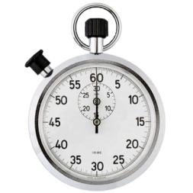
- Give yourself plenty of time for testing
  - Target 1 week of full testing
- Make a list of everything that failed and mark off those things as you fix them
- The more times you test, the more you will ‘know’ your machine! It will run more consistently. You will be able to set it up faster. You will uncover all the potential failures.
- Video tape the runs so you can see failures better
- Time how long the machine runs so you can hit a specific time goal

- Performance Phase
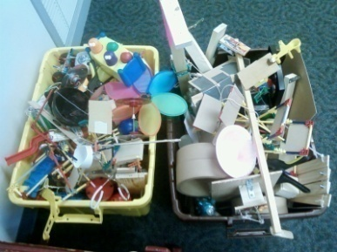
- Transportation
  - Expect something to break, it always does
- Go above and beyond for the judges
  - Do something that promotes the spirit of the competition. Something that is original and they will be pleasantly surprised by
    - Examples:
      - a mini-machine for the observers to play with
      - stickers for the audience, food for the audience (gumballs)
      - post funny signs around the machine, provide “How to Guide” for the ‘Young Rubes’
      - think of something interactive
      - have music
      - lots of lights
      - post pictures of the building process

Need Help or Inspiration?

I hope this guide has inspired you to become involved with this event and building Rube Goldberg Machines. I hope you’ve gained an appreciation for science, physics, chemistry, mechanics, electricity, and technology.
Good news! There is a website with all kinds of information, inspiration, videos, and contests!
www.rubegoldbergmachineworld.weebly.com
I would be glad to help you start your own machine or provide encouragement and inspiration. If I can help you further in any way, please email me at: asmakin@hotmail.com.

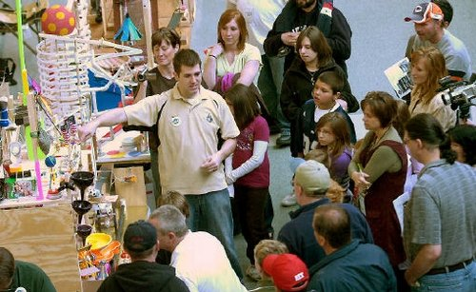
Aaron Makin

